**Unit 3**

**Q.1) Create an HTTP server and perform operations on it.**

1. **understand http request module :**

var http = require('http'); // 1 - Import Node.js core module

var server = http.createServer(function (req, res) { // 2 - creating server

//handle incomming requests here..

res.write("Hello Server");

res.end();

});

server.listen(5000); //3 - listen for any incoming requests

console.log('Node.js web server at port 5000 is running..')

Output :

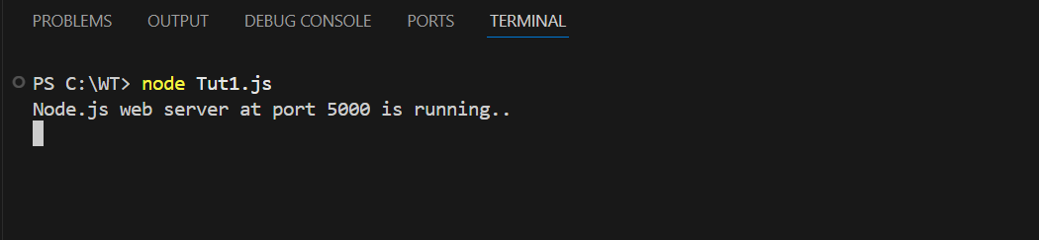

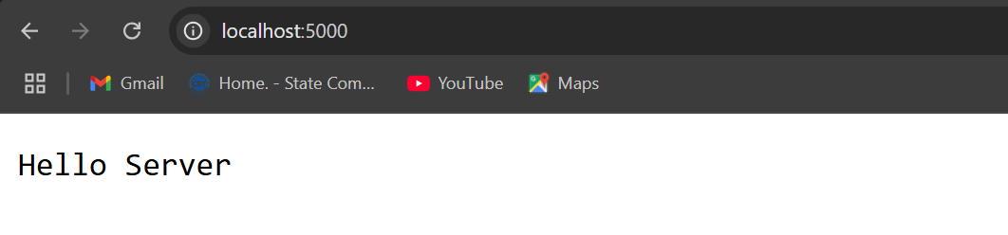

1. **routing :**

//understand routing in http module

var http = require('http'); // Import Node.js core module

var server = http.createServer(function (req, res) { //create web server

if (req.url == '/') { //check the URL of the current request

// set response header

res.writeHead(200, { 'Content-Type': 'text/html' });

// set response content

res.write('<html><body><p>This is home Page.</p></body></html>');

res.end();

}

else if (req.url == "/student") {

res.writeHead(200, { 'Content-Type': 'text/html' });

res.write('<html><body><p>This is student Page.</p></body></html>');

res.end();

}

else if (req.url == "/admin") {

res.writeHead(200, { 'Content-Type': 'text/html' });

res.write('<html><body><p>This is admin Page.</p></body></html>');

res.end();

}

else

res.end('Invalid Request!');

});

server.listen(5000); //6 - listen for any incoming requests

console.log('Node.js web server at port 5000 is running..')

Output :



Home page :



Student page :



Admin page :

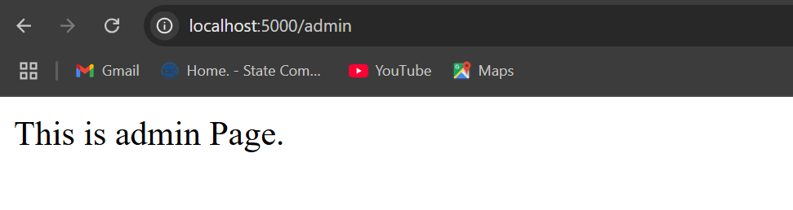

**Q.2) Using File Handling operations demonstrate all basic operations(Create, Write, Read, Delete).**

1. **Reading File**

var fs = require('fs');

fs.readFile('input.txt', function (err, data) {

if (err) throw err;

console.log(data.toString());

});

Ouput :

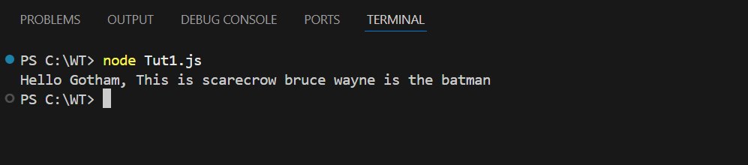

1. **Writing to a file**

var fs = require('fs');

fs.writeFile('test.txt', 'Hello Gotham ,Behold the almighty Ras-al-ghul

! ', function (err) {

if (err)

console.log(err);

else

console.log('Write operation complete.');

});

Ouput :

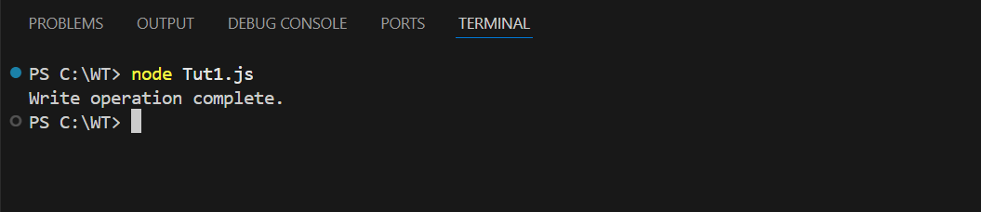

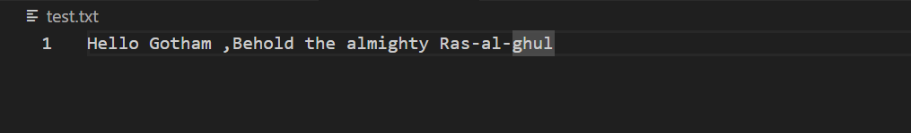

1. **Delete the file**

var fs = require('fs');

fs.unlink('test.txt', function () {

console.log('delete operation complete.');

});

Ouput :

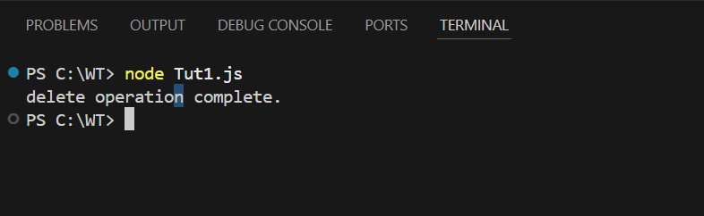

1. **Update file**

const fs = require('fs');

function updateFile(filePath, newContent) {

fs.writeFile(filePath, newContent, 'utf8', (err) => {

if (err) {

console.error(`Error updating the file: ${err.message}`);

} else {

console.log('File updated successfully!');

}

});

}

updateFile('input.txt', 'Peace has costed you strength! victory has defeated you');

Output :

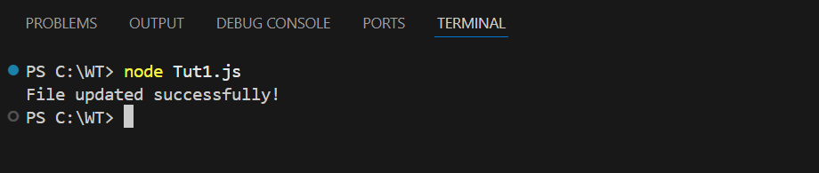

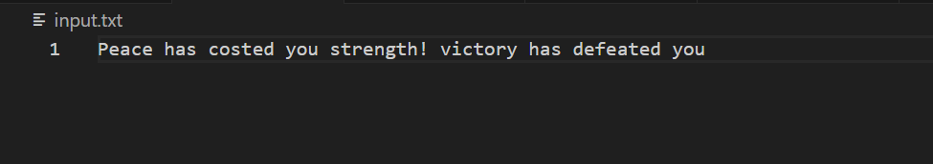

**Open a file :**

const fs = require('fs');

fs.open('input.txt', 'r', (err, fd) => {

if (err) {

console.error('Error opening file:', err.message);

return;

}

// Allocate buffer with modern API

const buffer = Buffer.alloc(10240);

fs.read(fd, buffer, 0, buffer.length, 0, (err, bytesRead) => {

if (err) {

console.error('Error reading file:', err.message);

fs.close(fd, () => {}); // Ensure file is closed

return;

}

if (bytesRead > 0) {

console.log(buffer.slice(0, bytesRead).toString());

}

fs.close(fd, (err) => {

if (err) {

console.error('Error closing file:', err.message);

}

});

});

});

Output :

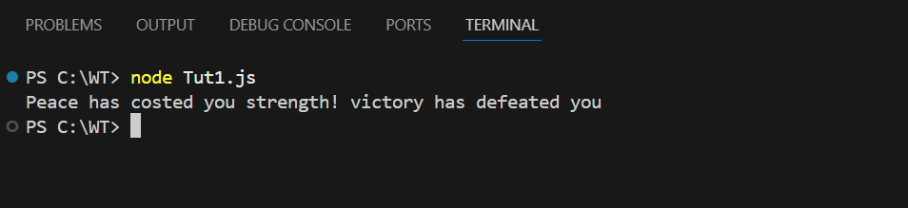

1. **Append to a file.**

var fs = require('fs');

fs.appendFile('input.txt',', This is Bane Speaking',function(err)

{

if(err)

console.log(err);

else

console.log('Append operation complete');

});

Output :

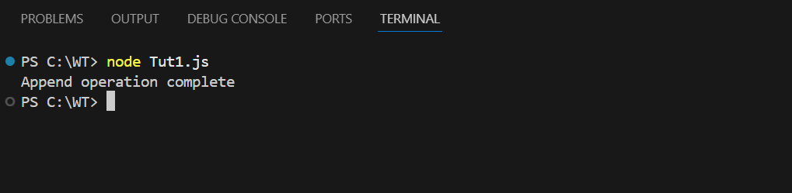

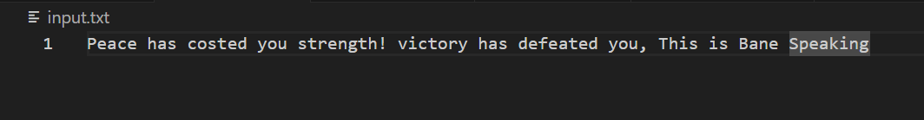

**Q.3) Create an application to establish a connection with MySQL database and perform database operations on it.**

1. **Database connectivity**

var mysql = require("mysql");

var con = mysql.createConnection({

host: "localhost",

user: "root",

password: "",

});

con.connect(function (err) {

if (err) throw err;

console.log("connected!");

});

Output :

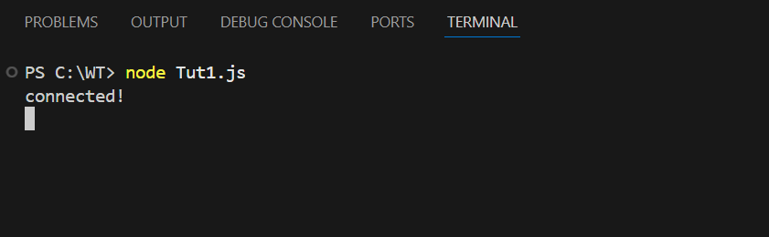

1. **Create database.**

var mysql = require('mysql');

var con = mysql.createConnection({

host: "localhost",

user: "root",

password: ""

});

con.connect(function(err) {

if (err) throw err;

console.log("Connected!");

con.query("CREATE DATABASE mydb", function (err, result) {

if (err) throw err;

console.log("Database created");

});

});

Ouptut :

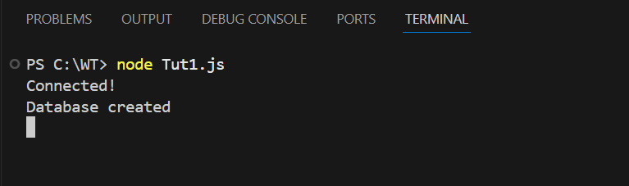

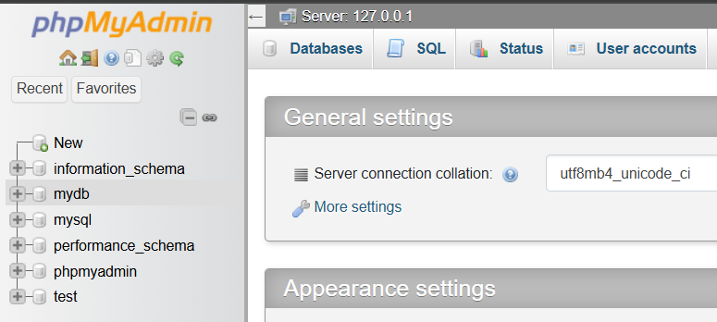

1. **Create a table in database.**

var mysql = require('mysql');

var con = mysql.createConnection({

host: "localhost",

user: "root",

password: "",

database: "mydb"

});

con.connect(function(err) {

if (err) throw err;

console.log("Connected!");

var sql = "CREATE TABLE customers (name VARCHAR(255), address VARCHAR(255))";

con.query(sql, function (err, result) {

if (err) throw err;

console.log("Table created");

});

});

Output :

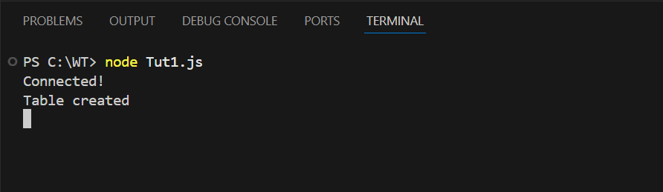

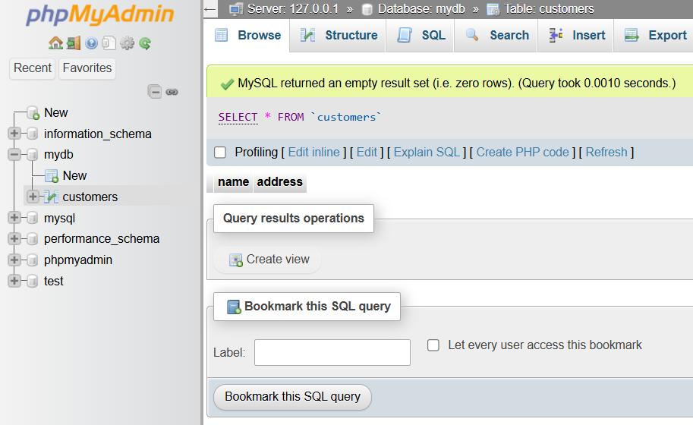

1. **Create table with primary key.**

var mysql = require('mysql');

var con = mysql.createConnection({

host: "localhost",

user: "root",

password: "",

database: "mydb"

});

con.connect(function(err) {

if (err) throw err;

console.log("Connected!");

var sql = "CREATE TABLE customers (id INT AUTO_INCREMENT PRIMARY KEY, name VARCHAR(255), address VARCHAR(255))";

con.query(sql, function (err, result) {

if (err) throw err;

console.log("Table created");

});

});

Output :

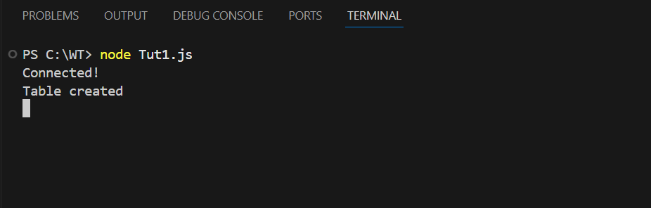

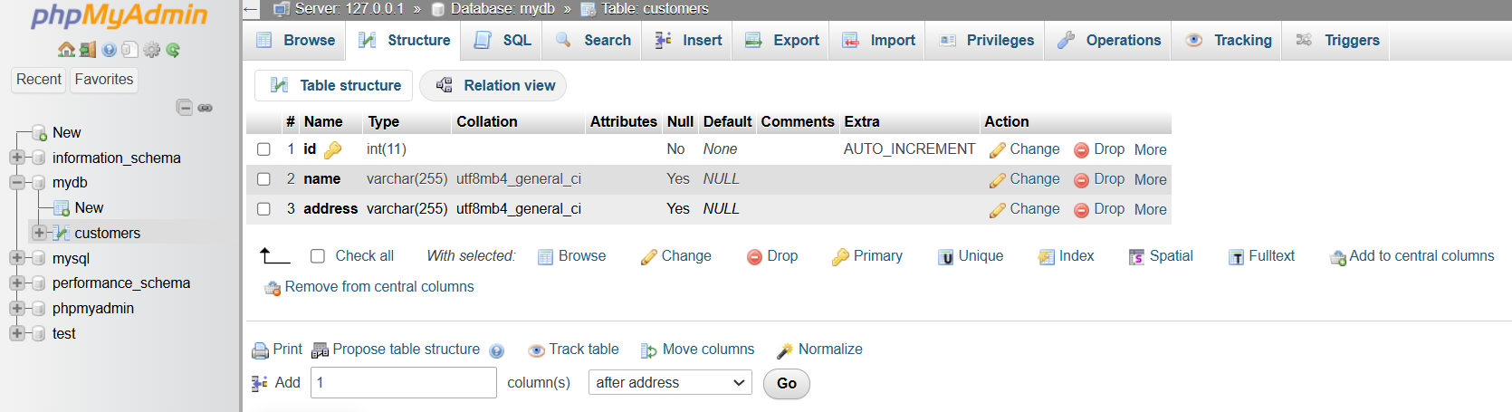

1. **Insert a record into table.**

var mysql = require('mysql');

var con = mysql.createConnection({

host: "localhost",

user: "root",

password: "",

database: "mydb"

});

con.connect(function(err) {

if (err) throw err;

console.log("Connected!");

var sql = "INSERT INTO customers (id, name, address) VALUES (1, 'Bruce', 'Gotham')";

con.query(sql, function (err, result) {

if (err) throw err;

console.log("1 record inserted");

});

});

Output :

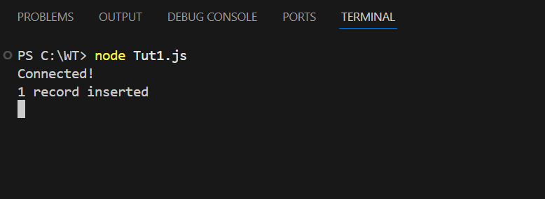

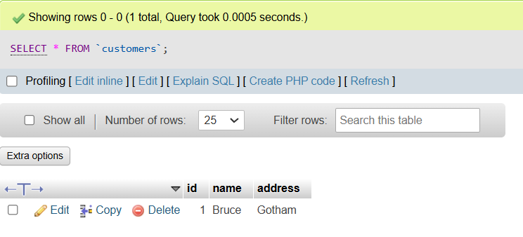

1. **Reading from a table.**

var mysql = require('mysql');

var con = mysql.createConnection({

host: "localhost",

user: "root",

password: "",

database: "mydb"

});

con.connect(function(err) {

if (err) throw err;

con.query("SELECT * FROM customers", function (err, result, fields) {

if (err) throw err;

console.log(result);

});

});

Output :

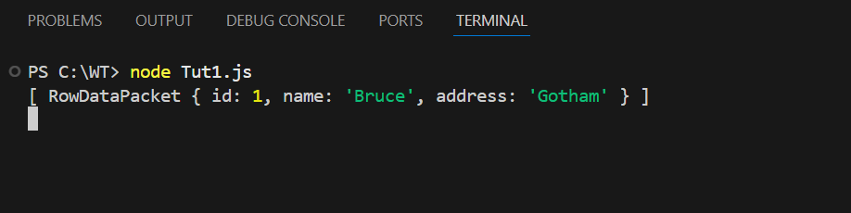

1. **Update a record in a table.**

var mysql = require('mysql');

var con = mysql.createConnection({

host: "localhost",

user: "root",

password: "",

database: "mydb"

});

con.connect(function(err) {

if (err) throw err;

var sql = "UPDATE customers SET address = 'Wayne Tower' WHERE address = 'Gotham'";

con.query(sql, function (err, result) {

if (err) throw err;

console.log(result.affectedRows + " record(s) updated");

});

});

Output :

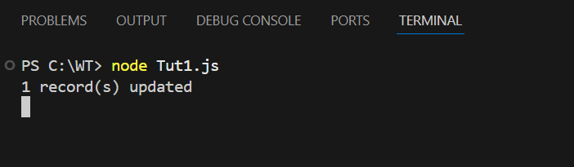

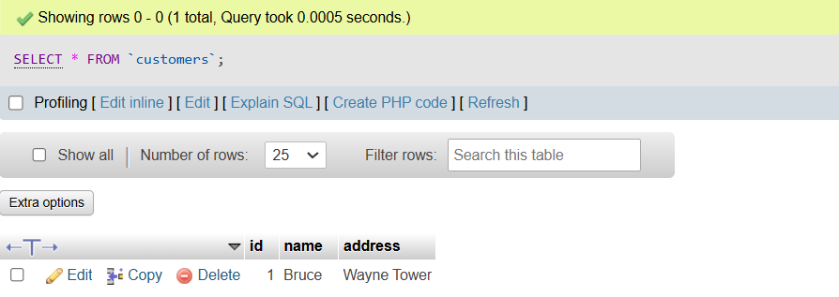

1. **Delete a record from table.**

var mysql = require('mysql');

var con = mysql.createConnection({

host: "localhost",

user: "root",

password: "",

database: "mydb"

});

con.connect(function(err) {

if (err) throw err;

var sql = "DELETE FROM customers WHERE address = 'Wayne Tower'";

con.query(sql, function (err, result) {

if (err) throw err;

console.log("Number of records deleted: " + result.affectedRows);

});

});

Output :

